**Supermarket Sales Analysis  
(January 2019 – March 2019)**

**ASSIGNMENT 1**

1. **Bar Chart – Total Sales by Product Line**

**Goal:** To analyse and compare total sales across different product lines in order to determine the top-performing category.

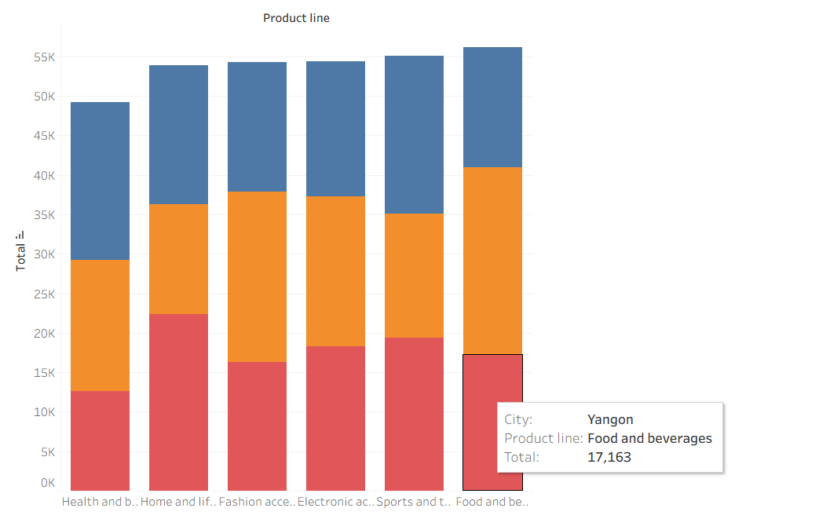

**2. Pie Chart – Payment Method Usage**

**Goal:** To represent the percentage distribution of transactions across different payment methods.

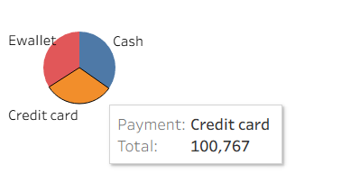

**3.Stacked Bar Chart – Sales by Gender in Each Product Line**

**Goal:** To analyse gender-based differences in sales across product lines.

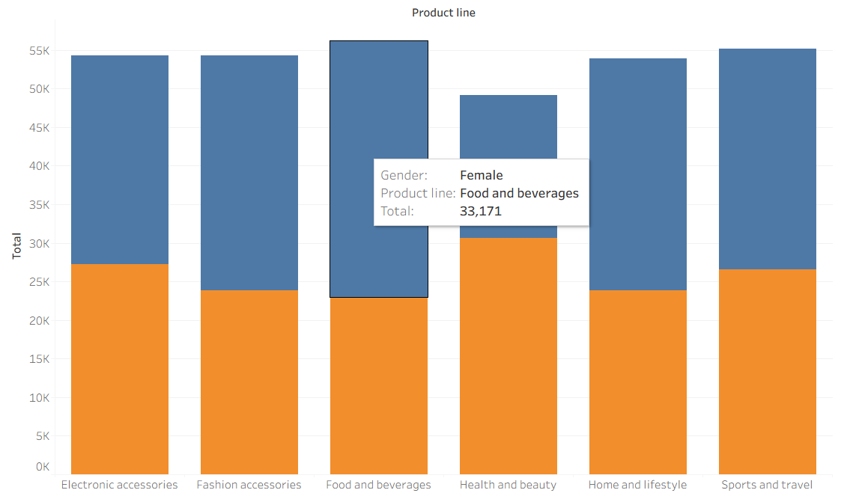

**4. Line Chart – Daily Sales Trend**

**Goal:** To analyse variations in daily sales to identify patterns and trends over the recorded time period

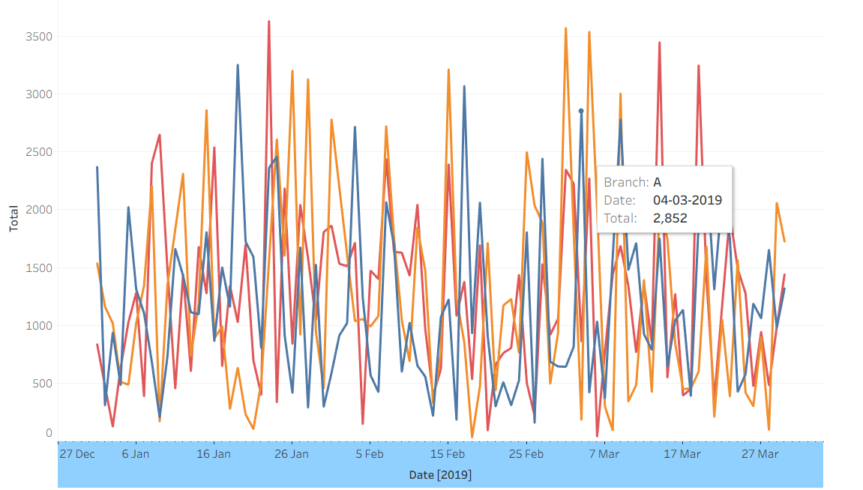

**5. Bubble Chart – Gross Income by City**

**Goal:** To highlight and compare the total gross income generated by each city.

